COT 3100 In-class Exercise 6

Name: USF ID:

**Problem 1 Prove statement by contradiction**

1. For any integer $a$, if $a mod 6=3,$ then $a mod 3≠2$.

Proof by contradiction:

Suppose not. That is suppose there is an integer $a$ such that $a mod 6=3$ and $a mod 3=2$. [We must deduce a contradiction].

By the quotient-remainder theorem, $a$ can be written in the form $a = 6q + 3=3k+2$ for some integer $s q and k$. This will give us $k-3q=\frac{1}{3}$, meaning $k-3q$ is not an integer.

However, $k-3q$ should be an integer since the products and difference of integers are integers and 3, $k$ and $q$ are integers. This is a contradiction. Therefore, if $a mod 6=3,$ then $a mod 3≠2$.

1. If $a, b ∈ Z$ and $a ≥ 2$, then $a$ not divides $b$ or $a$ not divides $(b+1)$.

Proof by contradiction:

Suppose not. That is suppose there are integer $s a$ and $b$ with $a ≥ 2$ such that $a\left|b\right.$ and $a\left|(b+1)\right..$ By definition of divisibility, $b=ac$ and $b+1 = ad$ for some integers $c$ and $d$. Subtracting one equation from the other gives $ad - ac = 1$, so $a(d - c) = 1$. Since $a$ is positive, $d-c$ is also positive (otherwise $a(d-c)$ would be negative). Then $d - c$ is a positive integer and $a(d - c) = 1$, so $a = 1/(d - c) < 2$. Thus we have $a ≥ 2$ and $a < 2$, This is a contradiction. So, $a$ not divides $b$ or $a$ not divides $(b+1)$.

**Problem 2 Prove statement by contraposition**

1. Let $x ∈ Z$. If $x^{2} - 6x + 5$ is even, then $x$ is odd.

Proof by contraposition:

Suppose that $x$ is even. [We want to show that $x^{2} - 6x + 5$ is odd.] By definition of odd, $x = 2k$ for some integer $k$.

$x^{2} - 6x + 5={(2k)}^{2}-6\left(2k\right)+5$ by substitution

$$=4k^{2}-12k+5$$

$=2\left(2k^{2}-6k+2\right)+1$ by algebra

Let $t=2k^{2}-6k+2$. $t$ is an integer since the products, sums and differences of integers are integers and 2, 6 and $k$ are integers. So, $x^{2} - 6x + 5=2t+1$ for some integer $t$. By definition of odd, $x^{2} - 6x + 5$ is odd [as was to be shown].

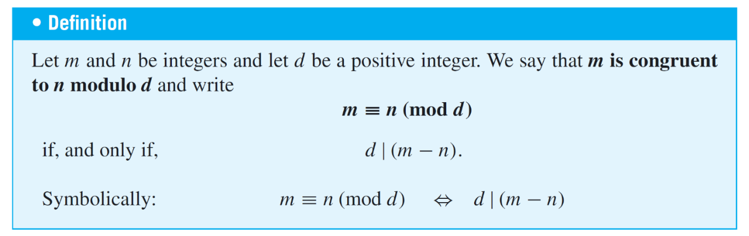

**Problem 3:** Prove the statement: let $d$ is a positive integer. The integers *m* and *n* are congruent modulo $d$ if and only if there is an integer $k$ such that $m = n + dk$.

$$m≡n \left(mod d\right) ⇔ ∃k ∈Z such that m=n+dk$$

Proof the statement: if $m≡n \left(mod d\right),$ then $∃k ∈Z such that m=n+dk$

Suppose $m$ and $n$ are any integers, and $d$ is a positive integer, such that $m≡n \left(mod d\right)$. By definition of congruence modulo, we have $d | (m - n)$. Thus, by definition of divisibility, $m-n=dk$ for some integer $k$. Adding *n* to both sides gives that $m=n+dk$.

Proof the statement: if $∃k ∈Z such that m=n+dk$, then $m≡n \left(mod d\right)$

Suppose $m$ and $n$ are any integers, and $d$ is a positive integer, such that $m=n+dk$ for some integer $k$. Subtracting $n$ to both sides gives that $m-n=dk$, where $k$ is an integer. By definition of divisibility, $d | (m - n)$. Therefore, by definition of congruence modulo $m≡n \left(mod d\right)$.